Leonard and Brown join the Lions
Jason Leonard and Steve Brown have been appointed to the board of the British & Irish Lions as representatives from the Rugby Football Union.

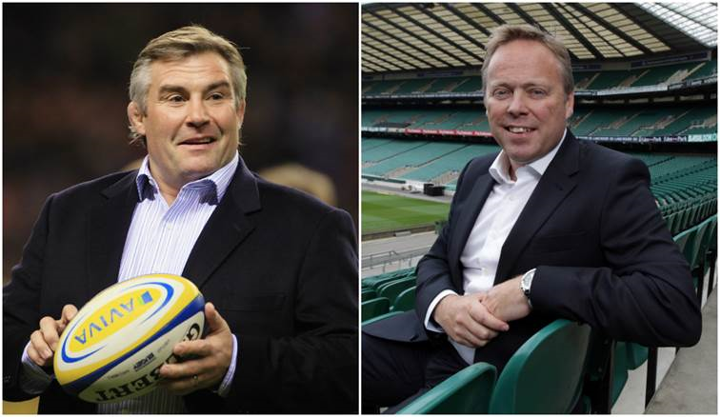
Past RFU President and Lion No 644 Leonard and RFU chief executive officer Brown replace 2017 tour manager John
Spencer and Ian Ritchie respectively.

“I’d like to thank John and Ian for their contribution to the Lions," said Lions board chairman Tom Grace.
"John did a fantastic job as Tour Manager in New Zealand and we wish him all the best in his RFU Presidency. Ian was the first RFU chief executive to sit on the Board and brought a lot of experience and expertise to the role. Again, we wish him well in his retirement.

“We welcome Jason and Steve to the Board. Jason is a three times Lions tourist (1993, 1997 and 2001) and will bring both a player and an administrator’s perspective. Steve’s recent appointment as CEO is testament to the confidence the RFU have in him and we believe the Lions will also benefit from his involvement.

“The appetite and support for the Lions has never been stronger and we are looking forward to Jason and Steve’s contribution.”

