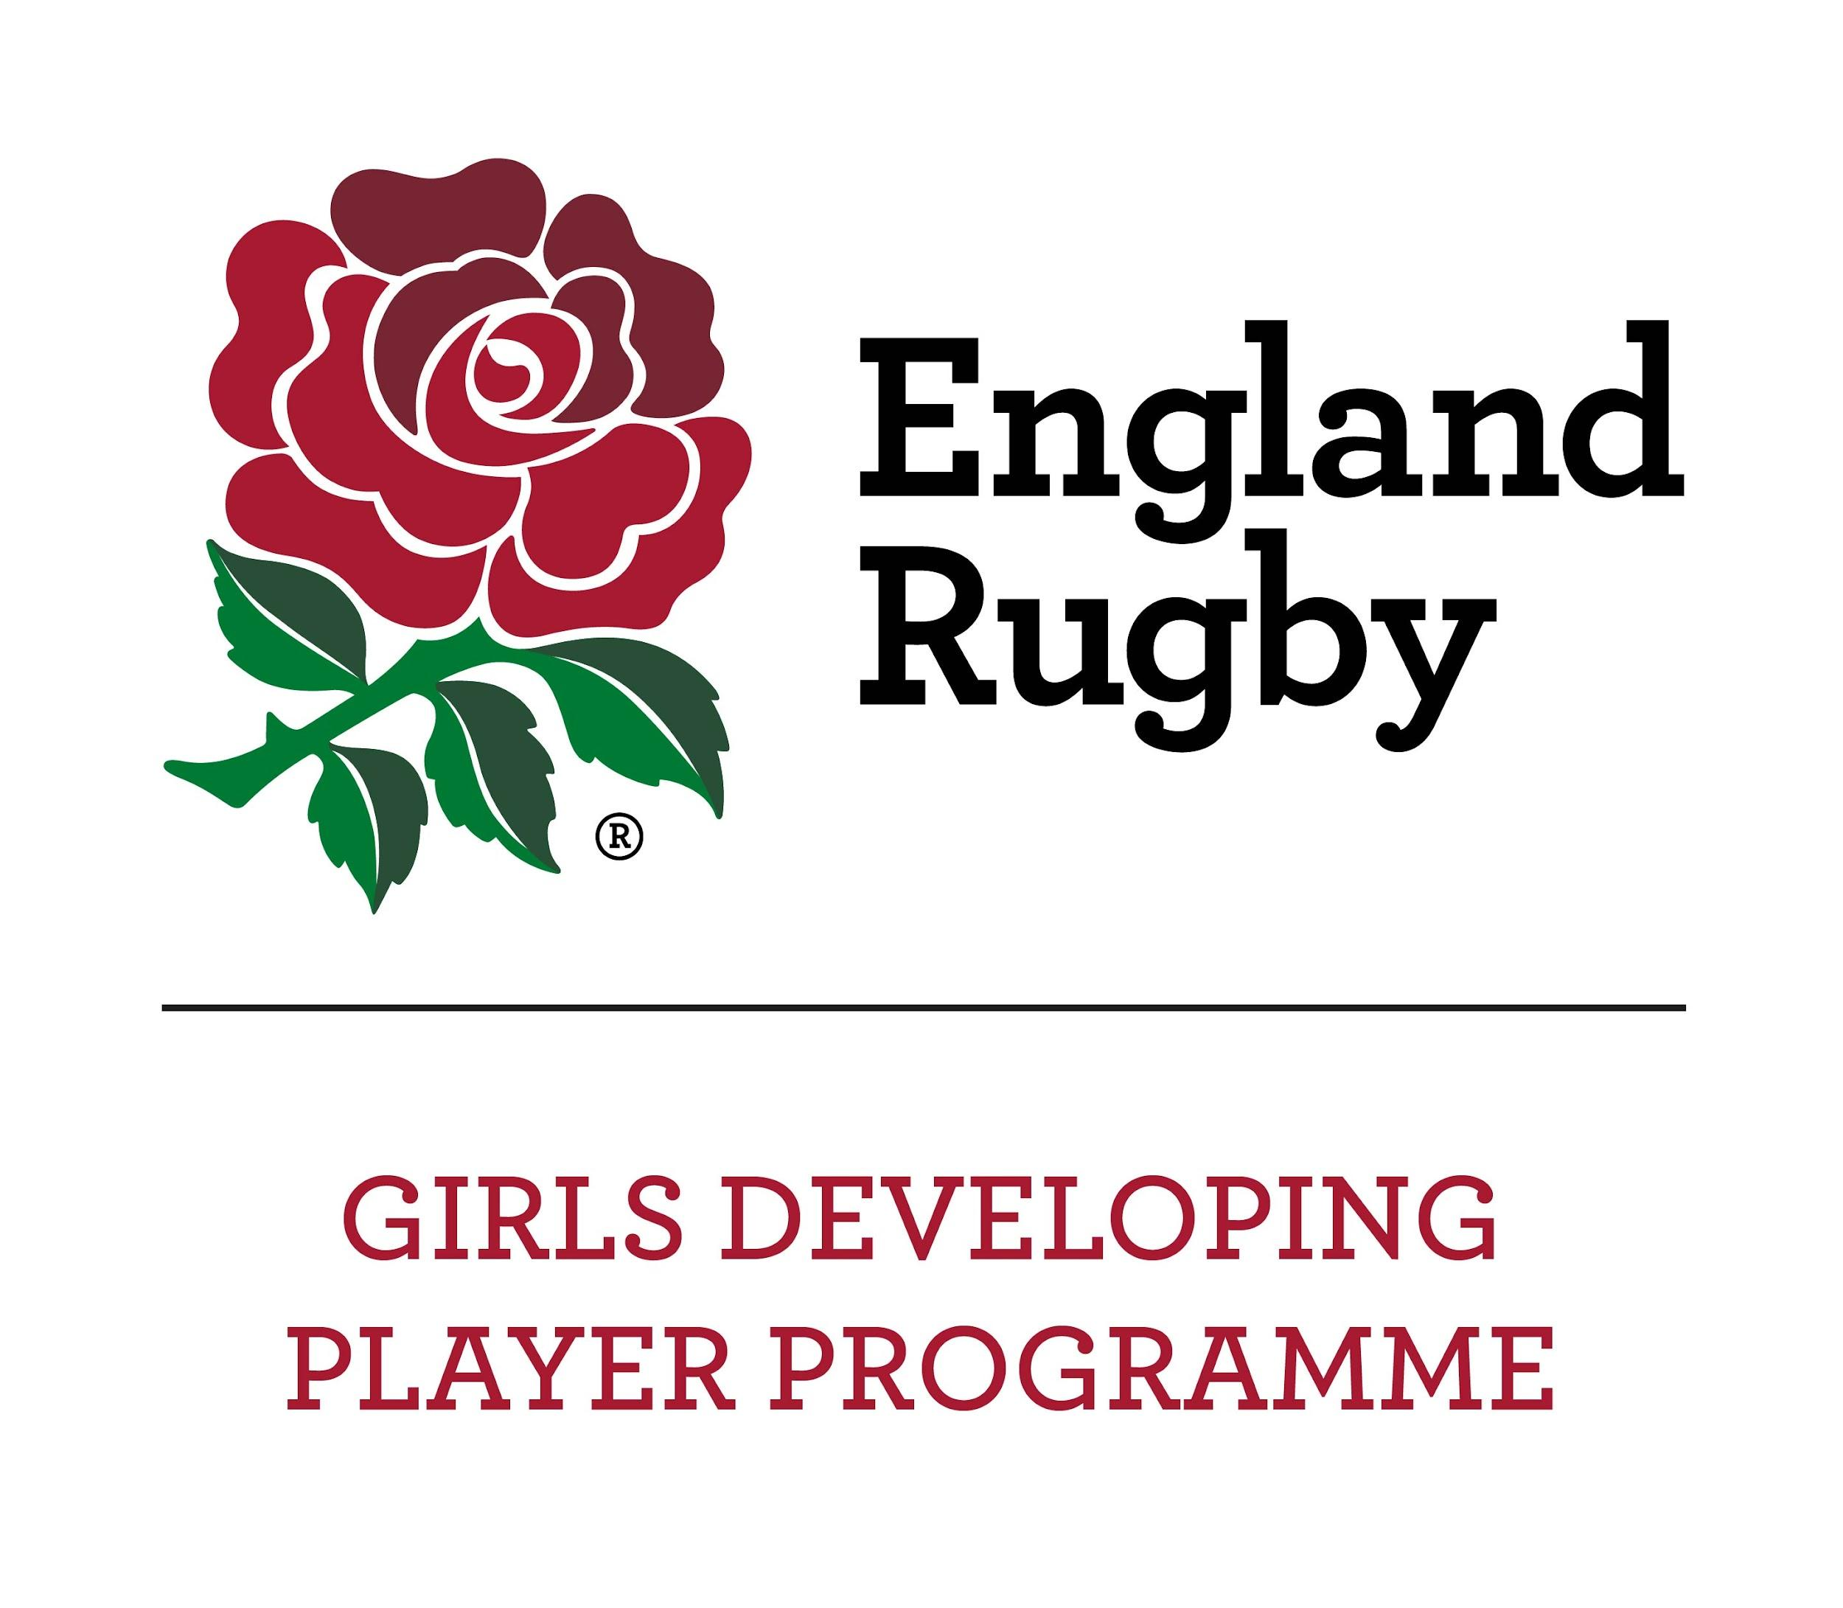
 | Forename | Surname
Name of Player

Date of Birth
Address

Post Code
Home Phone No.
School
Club
GMS/RFU Number
Parent / Guardian
Name of Parent/Guardian (1)
Contact Number
Email Address
Name of Parent/Guardian (2)
Contact Number
Email Address
Medical:
Please enter any relevant medical condition, prescribed medicines or allergies

Parental/Guardian Consent: Please read the following declaration carefully and sign and date beneath
My child/ ward is in good health and I consider her capable of taking part. I have completed the medical details and consent that, in the event of any illness/accident, any necessary treatment can be administered to my child, which may include the use of anaesthetics.
I also understand that while coaches and team personnel will take every precaution to ensure that accidents do not happen, they cannot necessarily be held responsible for any loss, damage or injury suffered to my child.
My attention has been drawn to the desirability of arranging insurance in respect of personal accident cover.
I am aware that the wearing of a mouthguard is in the best interests of players safety, as research has shown that this significantly reduces the incidence of dental injuries and as well as injuries to the mouth and lips and in the event of a collision reduces the likelihood of concussion.
I confirm that where a mouthguard could have prevented or lessened any injury sustained, I accept full responsibility for such injury.
I am aware that photographs may be taken for promotional purposes and give consent for my child to feature in such photos.

Print Name: Signature: Date:

We will not distribute any of the details above outside the ERDPP Girls rugby team manager, coaches, and relevant medical personnel. They will be stored securely and destroyed at the end of the season.

